2015年 12th annual 3D ASIP Conference
Koyanagi and Ramm win 3DIC Pioneering Award

URL
https://eps.ieee.org/component/content/category/11-awards.html
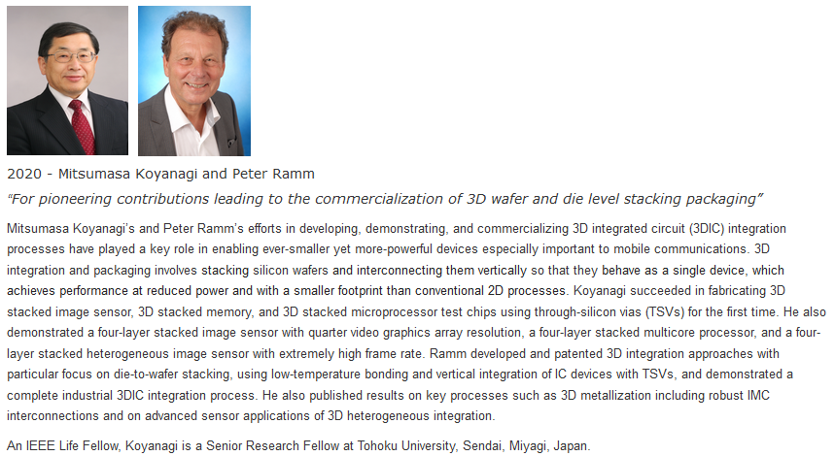
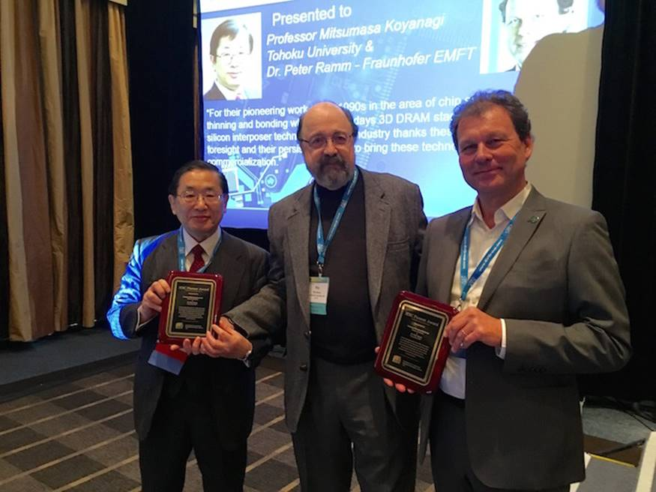

URL
https://sst.semiconductor-digest.com/2015/12/koyanagi-and-ramm-win-3dic-pioneering-award/
