2020 Electronics Packaging Award 紹介2件＝東北大(1ページ目)、IEEE(2ページ目)
[東北大]
URL
https://www.niche.tohoku.ac.jp/?p=3785
Electronics Packaging Award
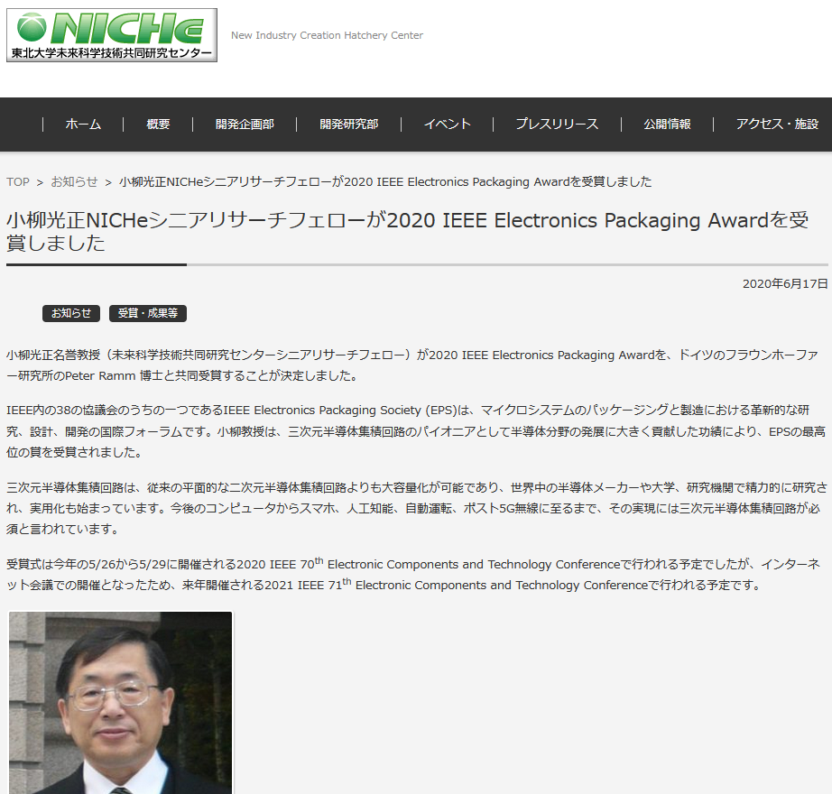

[IEEE]
URL
https://ieeetv.ieee.org/channels/ieee_awards/2020-2021-ieee-electronics-packaging-technology-award-mitsumasa-koyanagi-peter-ramm-chin-c-lee

